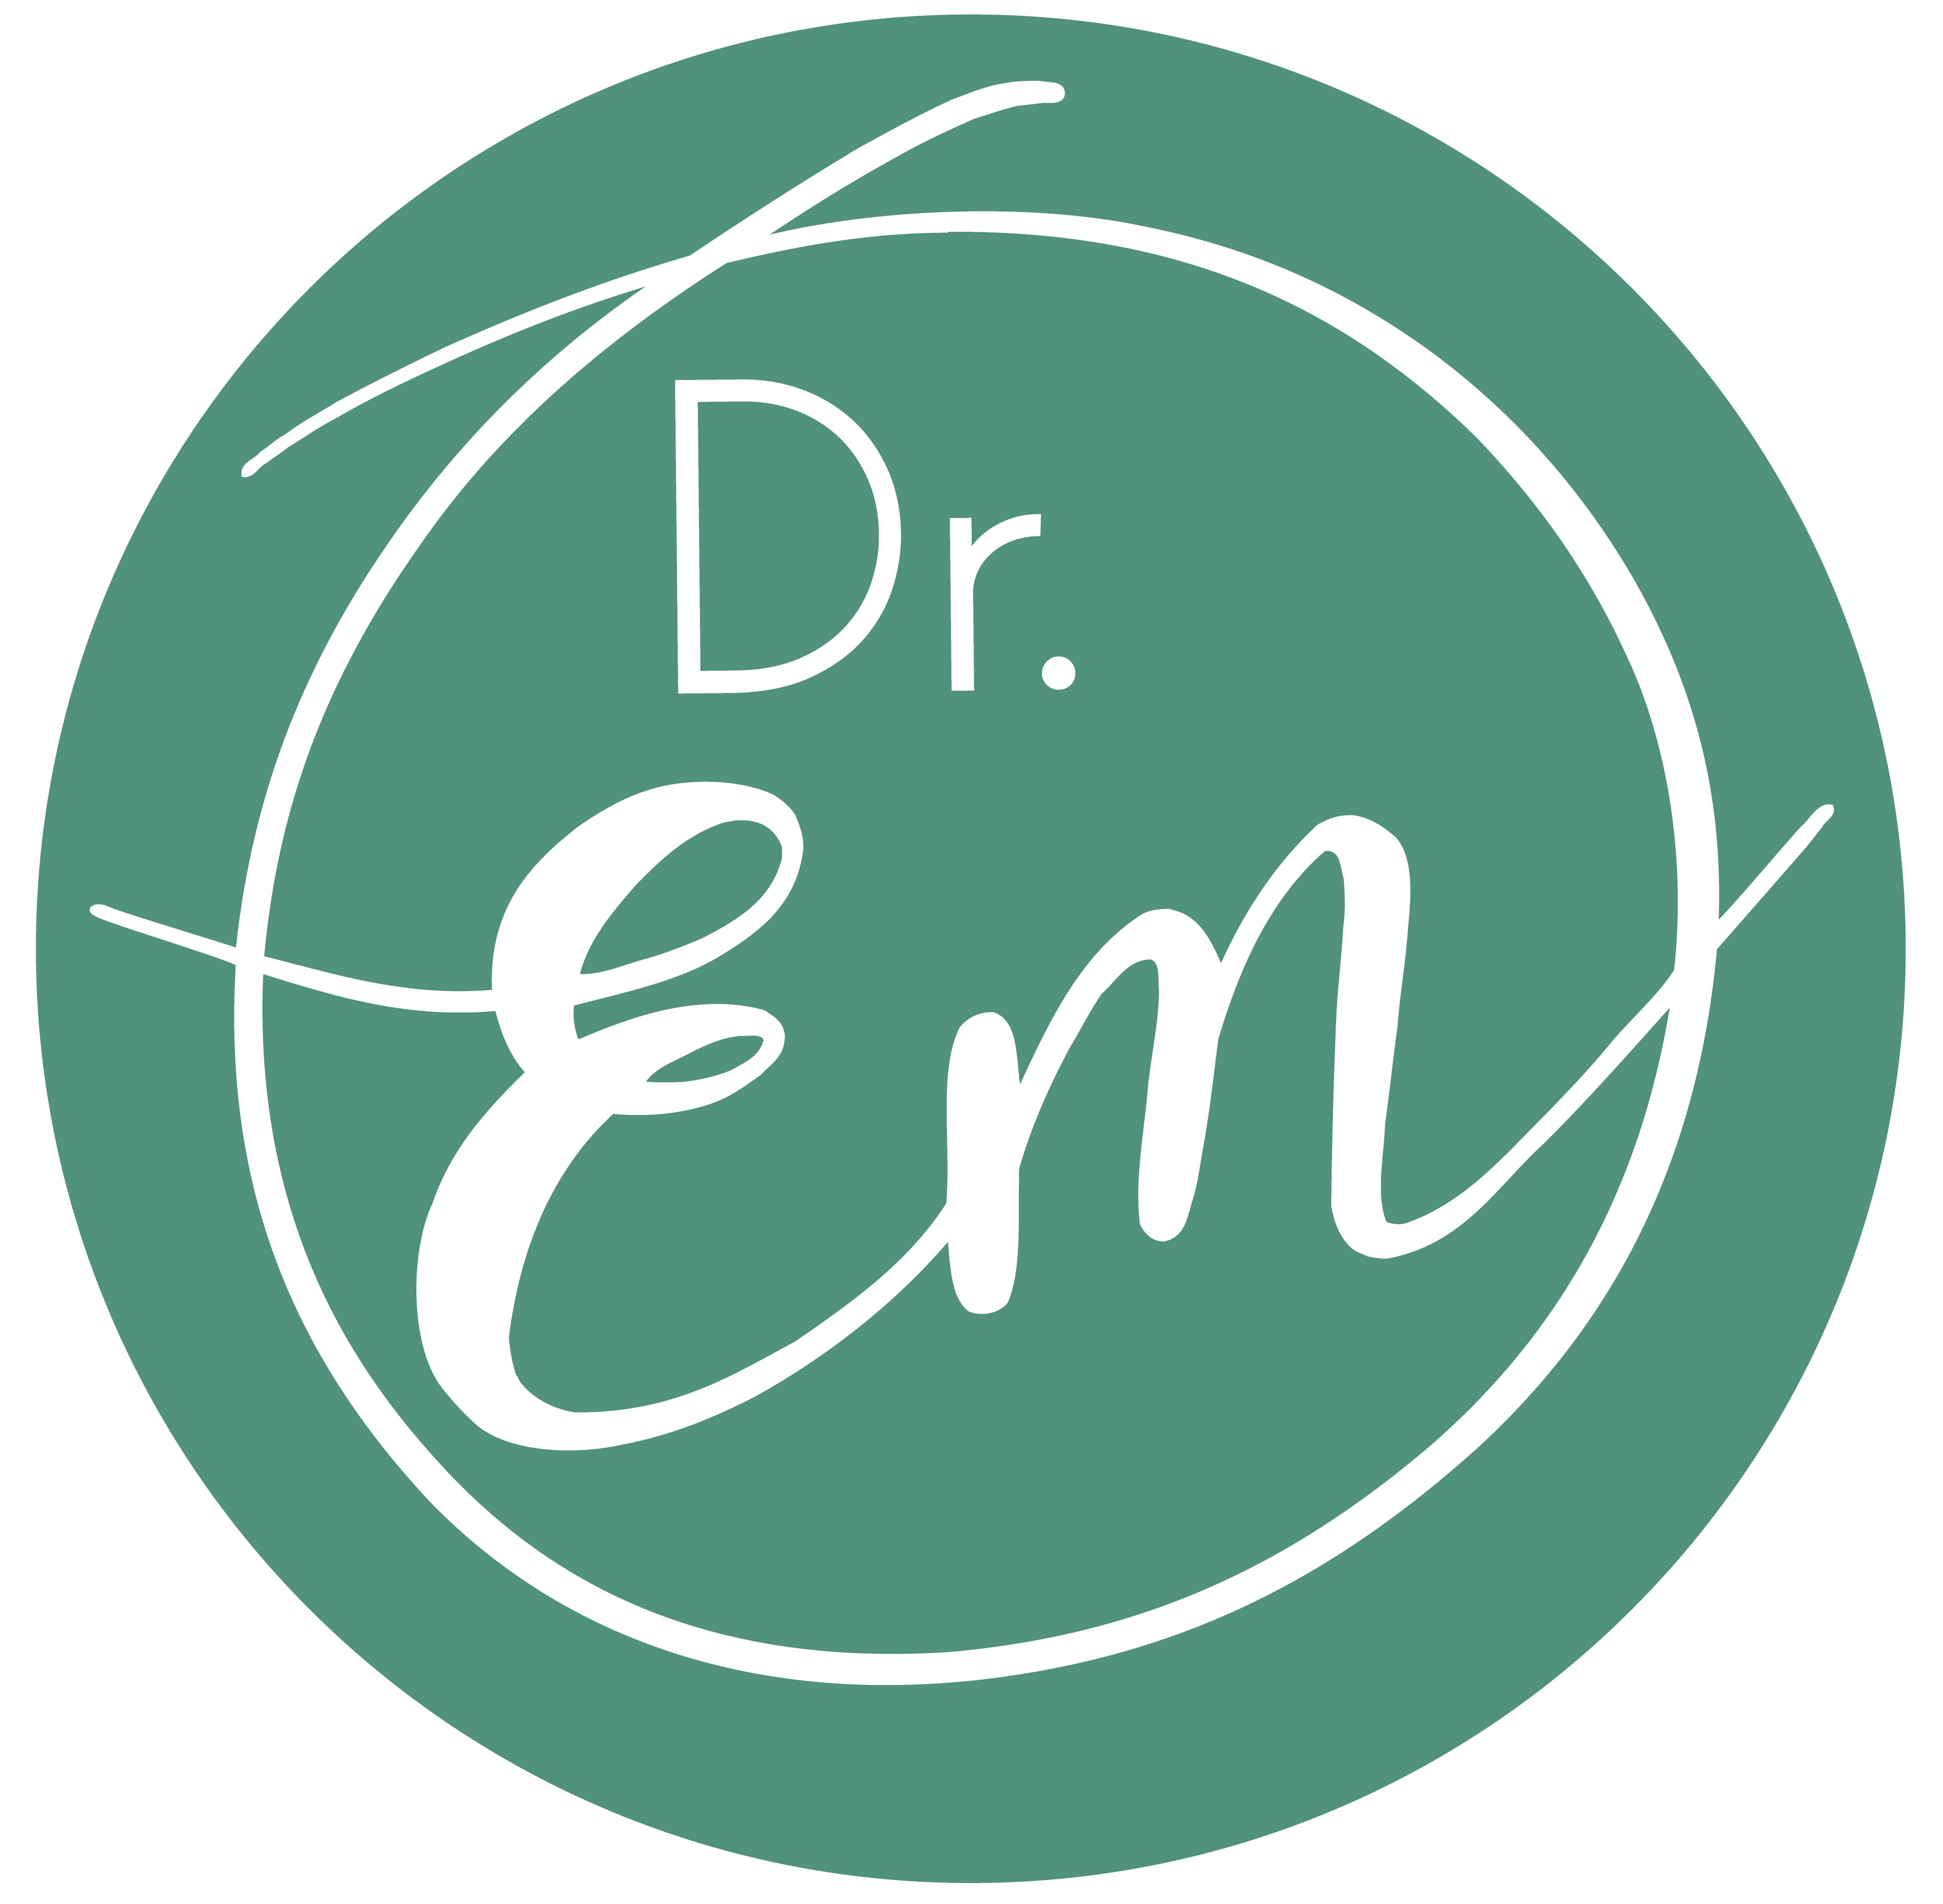 | DR. EMILY HARRISON  BSc, MBBS, FACRRM-AST EM
EDUCATION | 2023: Human Factors Short Course  - Monash University - Department of Anaesthesiology and Preoperative Medicine  2022: Advanced Leadership Program  - Women and Leadership Australia  2020: Clinical Governance Course  - Australasian Institute of Clinical Governance  2017: Fellowship and Advanced skills in Emergency Medicine  - Australian College of Rural and Remote Medicine  2011: Bachelor of Medicine, Bachelor of Surgery  - Deakin University, Geelong  2007: Bachelor of Science- Major: Pharmacology  - The University of Melbourne, Melbourne
PROFESSIONAL MEMBERSHIPS | 2013-Current: Member and Fellow  - Australian College of Rural and Remote Medicine  - 2023-Current: FARM Committee  - 2020-Current: ACRRM College Council- RDAA Representative  - 2019-Current: Respectful Workplaces Committee  - 2018-Current: Emergency Medicine Working Group  2019-Current: Board Member - Victoria representative  - Rural Doctors Association of Australia  - 2019-Current: Female Doctors Group Member  2013-Current: Board Member  - Rural Doctors Association of Victoria

CLINICAL EMPLOYMENT HISTORY | Dec 2023- Current: General Practitioner Headspace Swan Hill- Part time  - Headspace, Swan Hill District Health, Vic  May 2023-Current: Emergency Department SMO- Part Time  - Swan Hill District Health, Vic  April 2020-April 2023: Emergency Department Clinical Lead and Medical Education Officer- Full time  - Swan Hill District Health, Vic  Feb 2017-Jan 2020: Rural Generalist Locum in GP and Emergency Medicine  - Multiple Sites across Victoria, NSW, Qld and WA.  Feb 2015- Sept 2019: Emergency Department Senior Medical Officer - Part Time  - Echuca Regional Health, Vic  Feb 2015- Feb 2017: General Practice Registrar  - Mansfield Medical Clinic, Vic  2014: Emergency Medicine Advance Skills Training Registrar  - Bendigo Health Care Group and Echuca Regional Health, Vic  2012-2013: Intern and HMO 2  - Bendigo Health Care Group, Vic
PROFESSIONAL ENGAGEMENTS AND PRESENTATIONS: | May 2024: Presentations- Culture and Craft  - Victorian Rural Health Conference - Mildura  Oct 2023: Presentation -Medical Culture- It’s BS we can do better  - Rural Medicine Australia - Hobart  May 2023: Presentation - Medical Culture - Be Curious, Not Judgemental  - Victorian Rural Health Conference - Geelong  Jan 2023-Current: Adjunct Senior Lecture  - Charles Sturt University - School of Rural Medicine  2022-2023: TGA Women’s Health Products Working Group  - ACRRM Representative  2022- 2023: DRIVERS Conference  - Adjudicator  2021-Current: Advance neoResus Facilitator  - PIPER Neonatal Education  2021-Current: EM StAMPs and CTG StAMPs Examiner  - Australian College of Rural and Remote Medicine  2019-Current: HEART Course Content Development  - Australian College of Rural and Remote Medicine  2019-2021: EM StAMPs Study Group Lead Facilitator  - Australian College of Rural and Remote Medicine

