Remote Supervisor Pool Guide
Version 1/2025
Table of Contents
Introduction 3
Eligibility criteria 3
Training posts 3
Registrars 3
Approval Process: temporary remote supervisor 4
Application process 4
Stage 1: administration review 4
Stage 2: clinical assessment 5
Stage 3: regional context 5
The Role of the Remote Supervisor 5
ACRRM’s Training Requirements 6
Regional team involvement 7
Support 7
Temporary Remote Supervision allocation process 8
Training Post request for temporary remote supervisor 9
Pre-Commencement Meeting 9
Resources 10
Communication Pathways 10
Level of Competencies 11
Protected Teaching Time 11
Plan Approval Process 11
Documentation – supervision plan 11
Modification of the approved remote supervision arrangement 12
Financial remuneration 12
Remuneration process 13
Escalation process 13
Non-urgent escalation 14
Urgent escalation 14
Scenarios 15
Scenario 1: 3-month arrangement with nil concerns 15
Scenario 2: 3-month arrangement with a delayed return 15
Scenario 3: 3-month arrangement with a partial return to work 15
Appendix A 16

Introduction
Our supervisors are integral in the delivery of the Australian College of Rural and Remote Medicine’s (ACRRM) training program which prepares doctors to be Rural Generalist medical practitioners. By signing up to support our rurally based supervisors, the pool of remote supervisors is helping ACRRM to achieve its vision:
Healthy rural, remote and First Nations communities through excellence, social accountability and innovation.
Due to constraints associated with geographical isolation, remotely based supervisors struggle to attract back-up supervisor support. The Remote Supervisor Pool process is designed to mitigate the gap by providing a temporary supervisory resource to ensure seamless training and educational delivery for registrars in a structured format whilst protecting the safety of the community.
It should be noted that the maximum amount of time of any temporary remote supervision arrangement is 3 months. Extension beyond this period will trigger the formal accreditation process involving assessment of more permanent remote supervision models. Due to the temporary nature, this process is not designed to mitigate the supervisory component of formal accreditation processes.
This document should be in read in conjunction with Remote Supervision Guidelines and
Guide for Supervisors.

Eligibility criteria

Training posts
For a Training Post to be eligible to participate in the temporary remote supervision program they must be accredited and located in a Modified Monash Model (MMM) 5+ location, as per the Department of Health, Disability and Ageing’s Health Workforce Locator. MMM 4 sites will be assessed on a case-by-case basis without guarantee of a successful approval outcome.
Sites that have an accredited remote supervision model in situ are also eligible to apply to participate in the program to provide coverage to enable their remote supervisor to take leave.
The regional team will consider the training environment as well as the registrar’s competency levels when assessing the viability of the request.

Registrars
Reducing interruption to a registrar’s training program and maintaining continuity in the delivery of health services to the community is an important consideration. The staff at ACRRM have a responsibility to ensure that this is conducted in a safe and supportive manner without compromising the delivery of education. Therefore, with this consideration in mind, the regional team carefully evaluate submissions to assess that the suitability of the proposed plan.
Due to the financial recompense associated with flexible funding, registrars on the Independent Pathway are excluded from participating in this program.

Approval Process: temporary remote supervisor
Each application undergoes a merit-based assessment conducted at multiple levels.
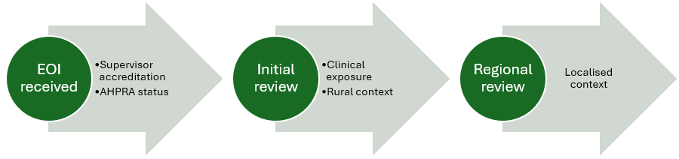

Application process
Clinicians wishing to be a part of the temporary remote supervisor pool need to submit their Expression of Interest via the ACRRM Career’s web page, clicking on the Apply button.
All applicants must provide a current copy of their CV so that we can analyse the applicant’s exposure to working within our diverse training landscape. This may also provide useful information in potentially matching an approved applicant to a post-in-need in a region that the supervisor has had prior clinical exposure.

Stage 1: administration review
An administration staff member initially conducts a review of the submission.

Supervisor accreditation status
Whilst we will accept Expressions of Interest (EOI) from practitioners who do not hold a current supervisor accreditation status with ACRRM, the expectation is that such applicants will undergo the supervisor accreditation process to be eligible to participate in the Temporary Remote Supervisor program*. The accreditation process maps the applicant’s suitability against ACRRM’s accreditation standards and is conducted by the post accreditation team. It should be noted that applicants have the option to apply to become:
- A standalone accredited supervisor unattached to a particular training post; or
- Accredited at a training post with an active accreditation status.
Please refer to the Supervisor and Training Post Accreditation Guide and the Supervisor Accreditation webpage for more information about the accreditation requirements.
* This requirement may be waivered if the applicant is currently employed by ACRRM in a clinical role and will be assessed on a case-by-case basis.

AHPRA Registration without Restrictions
As part of the initial assessment process, a review is conducted of the applicant’s Australian Health Practitioner Regulation Agency (AHPRA) registration to assess:
- That the level of registration is appropriate for the supervisory role and in keeping with ACRRM’s supervisor accreditation requirements
- For any conditions in place that may restrict the ability to effectively execute the supervisory role due to a restriction in scope of practice
Any registration with a condition will be assessed by the National Director of Training to ascertain potential implications, if any, upon the scope of the practice capabilities of the practitioner as associated restrictions may negatively impact upon the ability to effectively supervise an ACRRM registrar. If the scope of practice is too narrow, the application will not proceed, and any associated ACRRM supervisor accreditation will be withdrawn until such time as the restriction is resolved.

Stage 2: clinical assessment
Submissions that have successfully completed the administrative review are then forwarded to the National Lead ME Supervisor Support (NLMESS) for clinical assessment. This includes a review of the CV.

Clinical Exposure and Remote Medicine
Given the unique challenges faced by practitioners working in a geographically isolated location, an understanding of the nature of health delivery in a resource restricted environment is important in being able to effectively support ACRRM registrars remotely. The NLMESS undertakes a review of the applicant’s CV, analysing the experiences of the applicants to ascertain the applicant’s level of exposure in delivering medical interventions within a resource restricted environment.

Stage 3: regional context
The final stage of the review process requires input from the Regional Director of Training (RDoT) responsible for overseeing registrar training for the state in which the applicant is practicing. This informs the RDoT of the localised availability as well as providing further information to the national team managing the remote supervisor pool. The contextual understanding of the geographical landscape in which the health service is based provides a nuanced understanding of the supervision and support structure required to successfully delivery remote supervision.

The Role of the Remote Supervisor
The level of support provided to the registrar will vary, depending upon the competencies of the registrar and the complexities of the clinical environment in which the registrar is working. The adoption of a case-by-case approach will provide a personalised approach to assessing the needs of the registrar. Whilst it is most likely that delivery of the support arrangement will be conducted remotely, ACRRM may also request on-site assistance from the allocated temporary remote supervisor to conduct assessments such as Mini-CEXs or delivering pastoral care administrations.
It is expected that the temporary remote supervisor will deliver mandated training such as protected teaching time, corridor teaching and generalised support, as required by the registrar, in conjunction with the assessment performed by the regional team.
We also understand that there may be times when the allocated temporary remote supervisor is not available to support the registrar. To mitigate the risk to the registrar, the establishment of a backup contingency plan is important in ensuring the registrar can continue to deliver medical services in a supported and safe manner. This should be captured in the Temporary Supervision Plan.

ACRRM’s Training Requirements
An understanding of ACRRM’s curriculum is fundamental to the successful delivery of training support and educational delivery for registrars. It is highly recommended that supervisors complete the supervisor online modules to attain a comprehensive understanding of the principles of the role of the supervisor within the ACRRM training landscape. For detailed information about ACRRM’s training program, refer to the Rural Generalist Curriculum guide.
Foundational Education Tools
 | Foundations of Rural Generalist Supervision: Introduction | Exploration of supervisor as a dual professional: clinician and educator
 | Foundations of Rural Generalist Supervision: Supervision Placement | Identification of placement commencement tasks and why they matter.
 | Foundations of Rural Generalist Supervision: Supervision and Teaching | Review of the supervisor as a concept including a review of associated tasks.
 | Foundations of Rural Generalist Supervision: Consultation Observation and Feedback | How to effectively use this prime method to develop the supervised doctor’s consultation and communication skills
 | Foundations of Rural Generalist Supervision: Supervisors Problem Case Discussion | Approaches to Problem Case Discussion during teaching and lunchbreak sessions
 | Foundations of Rural Generalist Supervision: In-Practice Teaching | How to deliver planned teaching during protected teaching time
 | Foundations of Rural Generalist Supervision: Clinical Supervision and Random Case Analysis | A patient safety and educational delivery tool, Random Case Analysis is effective in gaining insight into a trainee’s clinical practice
 | ACRRM Cultural Safety | Provision of introductory knowledge and understanding of Aboriginal and Torres Strait Islander People’s beliefs, values, cultures and experiences.

ACRRM Assessment Focused Training
 | MiniCEX Training Course for Clinicians | An interactive module that provides resources, reference lists and practical opportunities to foster an understanding of the MiniCEX assessment process
 | Introduction to  MCQ Assessment | Not only does this course develop an understanding of MCQ assessments,  it equips participants with the skills to develop MCQs
 | Introduction to  CBD Assessment | Fosters a greater understanding of the CBD assessment including identification of the clinical and operational parameters of CBD construction
 | Introduction to StAMPS Assessment | Enhances a greater understanding of the StAMPS assessment piece including the context and structure of this assessment

Regional team involvement
The state-based team in which the registrar is undertaking training will be responsible for overseeing the approval and implementation processes of the temporary remote supervision plan. They have the detailed knowledge of the registrar’s training and support needs as well as the localised understanding of the training environment.
To connect with a specific member of the regional team, contact the regional team via the email alias for the state in which the registrar is training, as per below:
State | Email Alias
New South Wales | Training.nswact@acrrm.org.au
Northern Territory | Training.nt@acrrm.org.au
Queensland | Training.qld@acrrm.org.au
South Australia | Training.sa@acrrm.org.au
Victoria | Training.vic@acrrm.org.au
Western Australia | Training.wa@acrrm.org.au

Support
Regional team members provide support to Registrars, Supervisors and Practice Managers:
- Regional Director of Training (RDoT)
The RDoT has clinical responsibility to oversee the delivery of ACRRM’s training program in their allocated state.
- Training Network Coordinator (TNC)
The TNC is responsible for the administrative elements of delivering ACRRM’s training program and play a large role in relationship management in the state they oversee.
- Team Leader (TL)
Working in a 2IC capacity, the TL provides support to the TNC in the management of the administrative processes.
- Training Program Advisor (TPA)
TPAs provide administrative support as well as facilitate connections between key external stakeholders with appropriate members of their regional team. The TPA manages the administrative support for an allocated pool of registrars and training posts.
- Training Administration Officer (TAO)
Providing administrative support for the regional teams, the TAO is also responsible for facilitating travel arrangements and processing financial claims including temporary remote supervisor invoices.
Registrars have access to targeted supports:
- Medical Educator (ME)
Each registrar is allocated an ME who provides training support and pastoral care. Whilst acting as an advocate for their allocate registrars, their intimate knowledge of the registrar’s training trajectory positions the ME as someone who can provide practical advice for supervisors specific to the registrar’s training plan.
- Registrar Liaison Officer (RLO)
The RLO system is a peer-led program designed to provide registrars with a support network with built-in advisory and advocacy capabilities.
Supervisors also have access to targeted support:
- Supervisor Liaison Officer (SLO)
At a minimum, each regional team has at least one SLO member who acts as an advocate for supervisors, facilitating a support structure to enable the supervisor in executing the supervisory requirements in accordance with mandatory ACRRM requirements. They are a valuable resource, dispensing practical advice in managing ACRRM registrars and can facilitate a deeper understanding of the ACRRM curriculum requirements.

Temporary Remote Supervision allocation process
In most cases an email will be sent to the temporary remote supervisor pool, asking for availability. In some circumstances, a direct match to a specific temporary remote supervisor may be facilitated based upon their knowledge of the training environment and/or if their skillset directly meets a registrar’s identified training needs.
Refer to Appendix A for a detailed flow chart of the approval and allocation process.

Training Post request for temporary remote supervisor

Planned supervisor leave
In most cases, the request for allocation of a temporary remote supervisor will be planned in advance to cover supervisor leave for professional development opportunities and/or annual leave. Other scenarios may include (but are not limited to) the accredited supervisor:
- Undergoing planned medical procedures
- Falling sick or requiring unplanned medical procedures
- Resigning resulting in a temporary gap in the supervision schedule
- Experiencing a delay in the commencement, leaving a temporary gap in the supervision schedule

Regional approval
Whilst the goal is to minimise interruption to a registrar’s training plan, ACRRM have a responsibility to ensure that the registrar has an adequate support structure in place to dispense health services to their local community in an appropriate and safe manner. Therefore, escalation to the temporary remote supervisor pool will occur only once the regional team have ascertained that it is appropriate to do so.
The regional team representatives are also involved in the approval of the temporary remote supervisor allocation process, including the direct matching to meet a registrar’s needs based on geographical knowledge and/or skillset of a temporary remote supervisor. The regional team also review and approve all proposed temporary training plans that involve registrars training within their allocated geographical footprint.

Initial Provision of information
An important element of the request process is the provision of sufficient information to members of the temporary remote supervision pool, enabling the evaluation process to ensure the registrar support and training requirements match the delivery capacity of potential temporary remote supervisors.
For details regarding the provision of information, refer to the Request for a Temporary Supervisor form.

Pre-Commencement Meeting
Upon confirmation the allocated temporary remote supervisor should set up a time with the registrar to discuss the logistical processes around the delivery of the remote supervision model. It is recommended that the site contact, such as the practice manager, is involved in the meeting to facilitate a deeper understanding of the arrangements.
The collated information will guide the formulation of the temporary supervision plan.
For emergency arrangement, the meeting may take place after the temporary arrangement has commenced.

Resources
It is important for the allocated temporary remote supervisor to establish an understanding of the localised support structure the registrar is working within. This includes clinical and pastoral care resources.

Clinical resources
Identification of clinical supports, including their role and proximity to the registrar’s training location, will provide guidance as to structure of support needed by the registrar from the temporary remote supervision arrangement. It is therefore important during the pre-commencement meeting to establish:
- Who are the localised supports (including their role/qualifications)
- The nature of the support
- Their availability to offer support
- Their physical proximity to the registrar

Pastoral care
It is recommended that the allocated temporary remote supervisor ascertain, during the pre-commencement interview, the registrar’s level of comfort with the support arrangements. An anxious registrar may need additional support structures put in place to ease them into the proposed arrangements which needs to be factored into the structure of support offered to the registrar. Factors to consider include:
- The registrar’s current level of anxiety
- Current pastoral structures including:
- Family support
- Social connections
- Work-based supports
- Presentations that create anxiety for the registrar
Refer to the escalation process for more information on how to advance an urgent scenario.

Communication Pathways
A core element of successful delivery of a remote supervision model is establishing clear lines of communication. The established methods of communication need to meet the needs of the registrar and the temporary remote supervisor. Therefore, it is important that the parameters of communication are clearly identified.
- Confirm preferred methods of communication
- Urgent clinical situations
- Non urgent clinical situations
- Contact details are up to date
- Availability of technology
- Stability of internet connection and mobile phone coverage
- Any times the temporary supervisor is likely to be unavailable
- Establish a backup plan such a local health provider or the emergency department at a tertiary hospital

Level of Competencies
Even though the ME has provided information about the registrar’s competencies, this is also an opportunity for the temporary remote supervisor to conduct their own assessment in order to establish safeguards, developing a list of presentations that the registrar must discuss with the remote supervisor. This may also inform the content of mandated education sessions.

Protected Teaching Time
A mutually agreed upon time should be set aside for protected teaching time, commensurate to the registrar’s level of training and in accordance with ACRRM’s guidelines. The scheduled times should be communicated to the practice manager by the regional team representative to ensure this time is quarantined in the registrar’s schedule.
A list of topics should be established in advance but may be modified as opportunities are organically identified during the placement. The educational focus may be shaped by future assessment goals and may require onsite attendance, as directed by ACRRM. Refer to the ME’s handover notes for more information.

Plan Approval Process
It is a requirement that all temporary remote supervision models are pre-approved by ACRRM prior to commencement. This is a safety mechanism as it enables review of the proposal to ensure that the proposed model:
- Matches the supervision and training needs of the registrar
- Offers sufficient protected teaching time, in alignment with ACRRM’s training requirements and commensurate to the registrar’s level of training
- Escalation processes are appropriate

Documentation – supervision plan
The proposed remote supervision arrangement is captured in the Temporary Supervisor Plan and submitted to the ACRRM regional team where it will undergo clinical review prior to approval. The information captured in this form should guide the fiscal allocation under the Flexible Funds entitlements which is documented in the Flexible Funds Application Guidelines, available on ACRRM’s website.

Modification of the approved remote supervision arrangement
As the estimation of required support is a predictive exercise, there are times when circumstances change which can impact upon the anticipated level of support required. Variation may include an extension of the duration of the agreed upon temporary remote supervision plan or a medical emergency requiring extensive input from the temporary remote supervisor to support the registrar.
Should an approved temporary remote supervision plan require modifications due to a change in circumstance, email the regional team, providing the following information:
- Email subject field: “URGENT change in temporary remote supervision plan”
- The body of the email should include:
- Name of the Training Post
- Name of the Registrar
- Reason for the alteration including an estimation of the timeline and/or alteration in hours
per week
- Any changes to on-site visitation requirements
- Additional information deemed relevant
The email will be escalated for review, undergoing an approval process to determine the best course of action based upon the provided information. A member of the regional team may contact the temporary remote supervisor, registrar and/or training post representative to gather further information that will assist in the evaluation process.
The situation initiating the change request and any follow-up information should be captured in
the final supervisor report.

Financial remuneration
Supervisors supporting registrars on an eligible training pathway in an eligible training term will attract payments under the National Consistent Payments (NCP) framework. Additionally, supervisors will be remunerated under the flexible funds arrangement:
- $150 per hour, as per the agreed supervision arrangement and teaching plan
- $300 per work-based assessment activity, as requested by ACRRM
- Travel and accommodation, as requested by ACRRM (refer to page 7 of the flexible funds guide)

Remuneration process
All invoices are managed by the regional teams. The allocated temporary remote supervisor is to submit invoices to their regional representative from the state in which the registrar is currently placed.
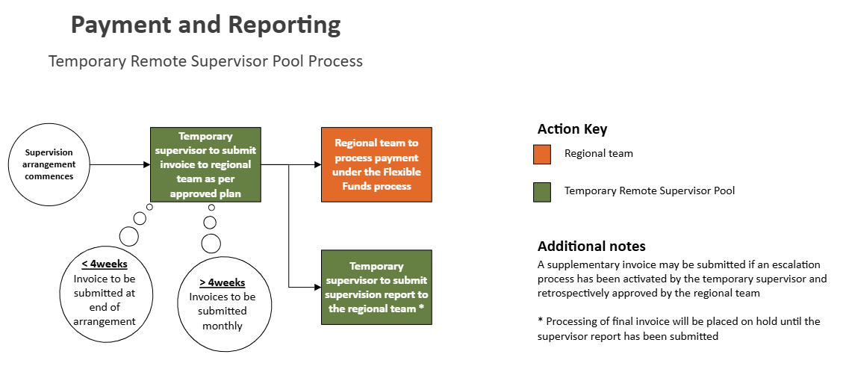
Regional contact details are available on the ACRRM website. The final payment request will not be processed until the supervisor report has been submitted.
Ad hoc additional funding outside of the agreed supervision plan may be approved by the regional team to support a registrar in distress or in unforeseen circumstances resulting in required additional support by the registrar.

Escalation process
Training as a Rural Generalist can be difficult to predict due to an increased scope of practice and scarcity of resources being commensurate with an increase in the MMM rating. Whilst in majority of cases the proposed supervision plan is indicative of the level of remote supervision support required by the supervisor, at times the situation may require the deployment of additional support by the allocated temporary remote supervisor.
The key focus should always be upon the safety of the registrar which may require the activation of additional clinical and pastoral care supports by the allocated temporary remote supervisor outside of the initial agreed upon scope of services.

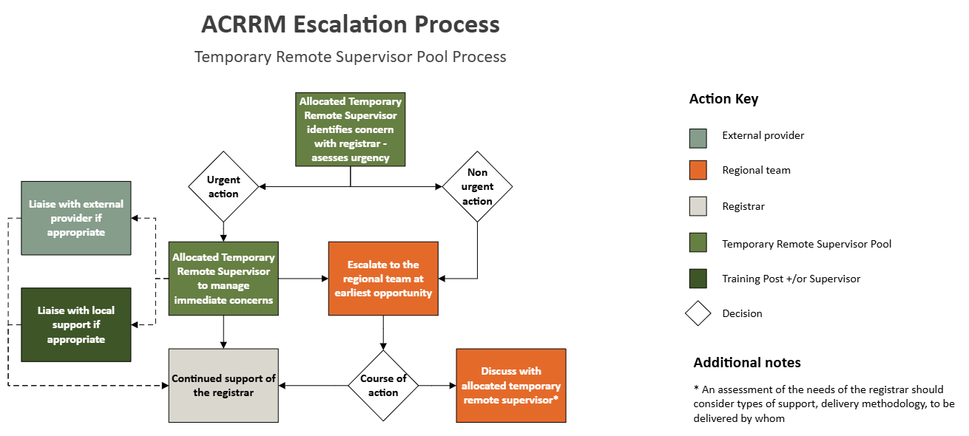
The level of urgency should be commensurate to the level risk to the safety of the community and/or registrar and may also relate to pastoral care matters. Any concerns should be escalated to the regional team as early as possible for assessment.

Non-urgent escalation
Evidence has shown early intervention with appropriate supports of an identified concern regarding a registrar’s performance increases the likelihood of the registrar successfully completing the training program. Identified concerns regarding a registrar’s performance, level of competency or lack of progression need to be escalated to the regional team for review.
Refer to the regional teams’ ACRRM web page for contact information.

Urgent escalation
There are a number of options available for a registrar identified by an allocated temporary remote supervisor as requiring urgent support. The following is a sample of immediate services that can be accessed:
Drs4Drs |    | 1300 374 377  drs4drs.com.au | - 24-hour support service  - Urgent mental health support  - For medical professionals
Lifeline |  | 13 11 14  lifeline.org.au | - 24-hour support service  - Suicide prevention services  - Mental health support
Note: all registrars are able to access a free and confidential Employee Assist Program that offers a supportive 24-hour counselling service. For more information visit the Wellbeing page on the ACRRM website.
Refer to the ACRRM Wellbeing support page on the ACRRM website for a comprehensive list of providers.

Scenarios
The following examples provide context as to the next course of action.

Scenario 1: 3-month arrangement with nil concerns

Dr Temporary is supporting a registrar for a 3-month period whilst Dr Supervisor is undergoing a medical procedure with a built-in recovery period.
The registrar has been assessed as being suitable to continue training under a temporary remote supervision and a plan has been developed by the allocated temporary remote supervisor. This has been assessed by the regional team as being appropriate. Dr Temporary contacts the registrar regularly, submitting invoices on a monthly basis for processing. At the completion of the arrangement Dr Temporary writes up their report which they submit, along with their final invoice, to the regional team.

Scenario 2: 3-month arrangement with a delayed return

Unfortunately, Dr Supervisor developed an infection which delayed his return to work by 4 weeks.
Normally a temporary remote supervision arrangement is capped at 3-months. Any delays are assessed on a case-by-case basis. Options include:
- Moving the registrar to another training post
- Registrar taking annual leave
- A temporary extension of the temporary remote supervision plan
In this instance the regional team opted for option 3 after discussion with the registrar and the current temporary remote supervisor, both of whom agreed to extend the current arrangement.

Scenario 3: 3-month arrangement with a partial return to work

Good news, Dr Supervisor made a really quick recovery and was able to return to work at the end of the 3-month hiatus. Unfortunately, they decided they only wanted to return in a part-time capacity, leaving a gap in the provision of on-site supervision.
In this scenario, extension of the current temporary remote supervision arrangement is not suitable due to the permanency of the requirement. This places the current training post’s accreditation into question as they no longer meet the ACRRM accreditation standards around on-site supervision.
The regional team are to notify the post accreditation team who commence the process of withdrawing the accreditation as a viable supervision alternative has not been identified.
As the registrar in question has passed all their assessments and only needs to complete 3 months of their primary care requirements in order to fellow, the regional team deemed it appropriate to generate an Individual Training Plan for the registrar to enable them to remain at the training post until fellowship. Happily, they remained at the training post and successfully applied to become an ACRRM supervisor which resulted in the training post becoming re-accredited again.

Appendix A
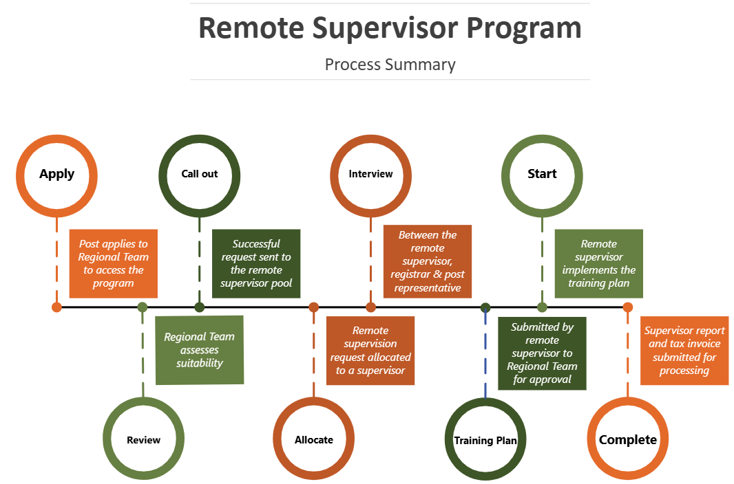
ACRRM acknowledges Aboriginal and Torres Strait Islander peoples as the custodians of the lands and waters where our members and staff work and live across Australia. We pay respect to their elders, lores, customs and Dreaming. We recognise these lands and waters have always been a place of teaching, learning, and healing.

