Remote Supervisor Pool Guide – Training Posts and Supervisors
Version 1/2025
Table of Contents
Purpose 3
What is it? 3
Eligibility 3
The training post 3
The registrar 4
The temporary remote supervisor 4
The application process 4
Initial submission 4
Review process 5
Allocation process 5
Pre-commencement interview 6
Funding 6
Escalation process 6
Non-urgent escalation 7
Urgent escalation 7
Scenarios 8
Scenario 1: 3-month arrangement with nil concerns 8
Scenario 2: 3-month arrangement with a delayed return 8
Scenario 3: 3-month arrangement with a partial return to work 8
Additional resources 9
Appendix A 10

Purpose
The Australian College of Rural and Remote Medicine (ACRRM) acknowledges the challenges faced by supervisors and training posts in delivering training to our future Rural Generalists. The more resource restrictive the environment, the bigger the challenge it is for the training posts and supervisors to access practical support.
The goal of creating a temporary remote supervisor pool is to provide an extra layer of support to our target demographic in a safe and structured manner. This fulfils ACRRM’s vision:
Healthy rural, remote and First Nations communities through excellence, social accountability and innovation.

What is it?
Through an Expression of Interest process, ACRRM have received submissions from experienced supervisors who are interested in the provision of registrar training support via a remote platform. The purpose of the program is to enable supervisors, who currently have an active ACRRM registrar placement and are working in a geographically challenging location, to take leave while the registrar remains supported at that post.
This program is not designed to provide workforce solutions that may otherwise be provided through the employment of locums. Any agreements relating to the provision of workforce solutions entered into by the training post and the allocated temporary remote supervisor is outside of this process.

Eligibility
The key to successful implementation of this initiative is to ensure that adequate safety checks have been put in place to deliver registrar support in a manner that protects the safety of the registrar and the community as a whole. Hence the request for the provision of a temporary remote supervisor must undergo stringent review.

The training post
For a Training Post to be eligible to participate in the temporary remote supervision program they must be accredited with ACRRM and located in a Modified Monash Model (MMM) 5+ location, as per the Department of Health, Disability and Ageing’s Health Workforce Locator. While MMM 4 sites will be assessed on a case-by-case basis, there is no guarantee of a successful approval outcome.
Sites that have an accredited remote supervision model in situ are also eligible to apply to participate in the program to provide coverage to enable their remote supervisor to take leave.
The regional team will consider the training environment as well as the registrar’s competency levels when assessing the viability of the request.

The registrar
Reducing interruption to a registrar’s training program and maintaining continuity in the delivery of health services to the community is an important consideration. The staff at ACRRM have a responsibility to ensure that this is conducted in a safe and supportive manner without compromising the delivery of education. With this consideration in mind, the regional team carefully evaluate submissions to assess that the suitability of the proposed plan.
Due to the financial recompense associated with flexible funding, registrars on the Independent Pathway are excluded from participating in this program.

The temporary remote supervisor
Each applicant undergoes a robust review process prior to acceptance as part of the temporary remote supervisor pool. Considerations include:
- Do they meet the accreditation standards as a supervisor? This includes a review of their current Australian Health Practitioner Regulation Agency (AHPRA) registration to assess for any conditions that may preclude eligibility to take on the supervisory role.
- An assessment of their clinical experience including their contextual understanding of delivering health services within a rural and remote context.

The application process
Our regional teams are positioned to understand the localised context of the health service setting. They also have an intricate knowledge of their allocated registrars including their learning needs. Given their depth of knowledge, the regional team members are the decision makers in the application assessment process.
Refer to Appendix A for an overview of the approval and allocation process.

Initial submission
Training posts that meet the eligibility criteria and have a registrar on a suitable training pathway need to complete the Request for a Temporary Remote Supervisor form, submitting the application to the local regional team for assessment.
State | Email Alias
New South Wales | Training.nswact@acrrm.org.au
Northern Territory | Training.nt@acrrm.org.au
Queensland | Training.qld@acrrm.org.au
South Australia | Training.sa@acrrm.org.au
Tasmania | Training.tas@acrrm.org.au
Victoria | Training.vic@acrrm.org.au
Western Australia | Training.wa@acrrm.org.au

It is important to establish a solid understanding of the training environment including the availability of localised support.

Review process
The regional team assess the suitability of the request based upon the information provided and the known learning needs of the registrar. This may involve a follow up discussion by a regional team representative and the training post to gather additional information that will assist in the decision-making process.
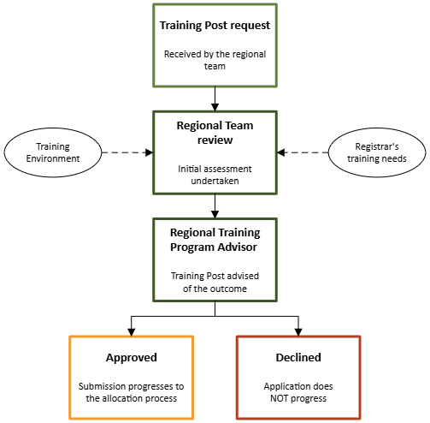

Allocation process
In most cases a request will be made to the temporary remote supervisor pool to check for capacity. A short-list of available supervisors is sent through to the Regional Director of Training (RDoT) who has the responsibility for overseeing registrar training in the region the training post is located. The RDoT will make the final allocation selection.
Occasionally, a targeted request will be made to a temporary remote supervisor where a specific need has been identified that can be met by the approached temporary remote supervisor. This is usually based upon the clinical experience of approached individual and may include a working knowledge of health services provision of the geographical location.

Pre-commencement interview
The training post representative and registrar will be notified once the allocation has been finalised. The allocated temporary remote supervisor will contact the registrar to establish a pre-commencement interview. During this interview the allocated temporary remote supervisor will:
- Gather information about the training environment including any available localised supports,
- Establish educational delivery including protected teaching time and areas of educational need,
- Assessment information that may identify any on-site visitation requirements and could shape the education delivery content,
- A contingency plan for situations where the registrar requires immediate clinical support, but is unable to connect with the allocated temporary remote supervisor.
It is advisable that a site administrator attend the meeting to ensure transparency in information transmission. This will enable the scheduling of protected teaching time and ensure that appropriate structures are established should the contingency support plan need to be activated in cases of emergency.

Funding
Supervisors supporting registrars on an eligible training pathway in an eligible training term will attract payments under the National Consistent Payments (NCP) framework. Allocated temporary remote supervisors will be remunerated under the flexible funds arrangement:
- $150 per hour, as per the agreed supervision arrangement and teaching plan which has been approved by the ACRRM regional team
- $300 per work-based assessment activity, as requested by ACRRM
- Travel and accommodation, as requested by ACRRM (refer to page 7 of the flexible funds guide)
This process is managed by the ACRRM regional team representatives and does not require any additional action on behalf of the training post representative.

Escalation process
Training as a Rural Generalist can be difficult to predict due to an increased scope of practice and scarcity of resources being commensurate with an increase in the MMM rating. In majority of cases the agreed supervision plan is indicative of the level of remote supervision support required of the allocated temporary remote supervisor by the registrar.
As the key focus should always be upon the safety of the registrar, this may require the activation of additional clinical and pastoral care supports by the allocated temporary remote supervisor outside of the initial agreed upon scope of services. The level of urgency should be commensurate to the risk level to the safety of the community and/or registrar including pastoral care considerations.
Any concerns should be escalated to the regional team as early as possible for evaluation.

Non-urgent escalation
Evidence has shown early intervention with appropriate supports of an identified concern regarding a registrar’s performance increases the likelihood of the registrar successfully completing the training program. Identified concerns regarding a registrar’s performance, level of competency or lack of progression need to be escalated to the regional team for review.
State | Email Alias
New South Wales | Training.nswact@acrrm.org.au
Northern Territory | Training.nt@acrrm.org.au
Queensland | Training.qld@acrrm.org.au
South Australia | Training.sa@acrrm.org.au
Tasmania | Training.tas@acrrm.org.au
Victoria | Training.vic@acrrm.org.au
Western Australia | Training.wa@acrrm.org.au

Urgent escalation
There are a number of options available for a registrar identified by an allocated temporary remote supervisor as requiring urgent support. The following is a sample of immediate services that can be accessed:
Drs4Drs |    | 1300 374 377  drs4drs.com.au | - 24-hour support service  - Urgent mental health support  - For medical professionals
Lifeline |  | 13 11 14  lifeline.org.au | - 24-hour support service  - Suicide prevention services  - Mental health support
Note: all registrars are able to access a free and confidential Employee Assist Program that offers a supportive 24-hour counselling service. For more information visit the Wellbeing page on the ACRRM website.
Refer to the ACRRM Wellbeing support page on the ACRRM website for a comprehensive list of providers.

Scenarios
The following examples provide context as to the next course of action.

Scenario 1: 3-month arrangement with nil concerns

Dr Temporary is supporting a registrar for a 3-month period whilst Dr Supervisor is undergoing a medical procedure with a built-in recovery period.
The registrar has been assessed as being suitable to continue training under a temporary remote supervision and a plan has been developed by the allocated temporary remote supervisor. This has been assessed by the regional team as being appropriate. Dr Temporary contacts the registrar regularly, submitting invoices on a monthly basis for processing. At the completion of the arrangement Dr Temporary writes up their report which they submit, along with their final invoice, to the regional team.

Scenario 2: 3-month arrangement with a delayed return

Unfortunately, Dr Supervisor developed an infection which delayed his return to work by 4 weeks.
Normally a temporary remote supervision arrangement is capped at 3-months. Any delays are assessed on a case-by-case basis. Options include:
- Moving the registrar to another training post
- Registrar taking annual leave
- A temporary extension of the temporary remote supervision plan
In this instance the regional team opted for option 3 after discussion with the registrar and the current temporary remote supervisor, both of whom agreed to extend the current arrangement.

Scenario 3: 3-month arrangement with a partial return to work

Good news, Dr Supervisor made a really quick recovery and was able to return to work at the end of the 3-month hiatus. Unfortunately, they decided they only wanted to return in a part-time capacity, leaving a gap in the provision of on-site supervision.
In this scenario, extension of the current temporary remote supervision arrangement is not suitable due to the permanency of the requirement. This places the current training post’s accreditation into question as they no longer meet the ACRRM accreditation standards around on-site supervision.
The regional team are to notify the post accreditation team who commence the process of withdrawing the accreditation as a viable supervision alternative has not been identified.
As the registrar in question has passed all their assessments and only needs to complete 3 months of their primary care requirements in order to fellow, the regional team deemed it appropriate to generate an Individual Training Plan for the registrar to enable them to remain at the training post until fellowship. Happily, they remained at the training post and successfully applied to become an ACRRM supervisor which resulted in the training post becoming re-accredited again.

Additional resources
- CHECKLIST Pre Commencement Supervisor and Registrar Meeting
- FORM CGT Remote Supervision Application Form
- FORM Placement Feedback REMOTE SUPERVISOR POOL
- FORM Request for a Temporary Remote Supervisor
- GUIDE Temporary Remote Supervisor Pool Program
- GUIDELINE Remote Supervision

Appendix A
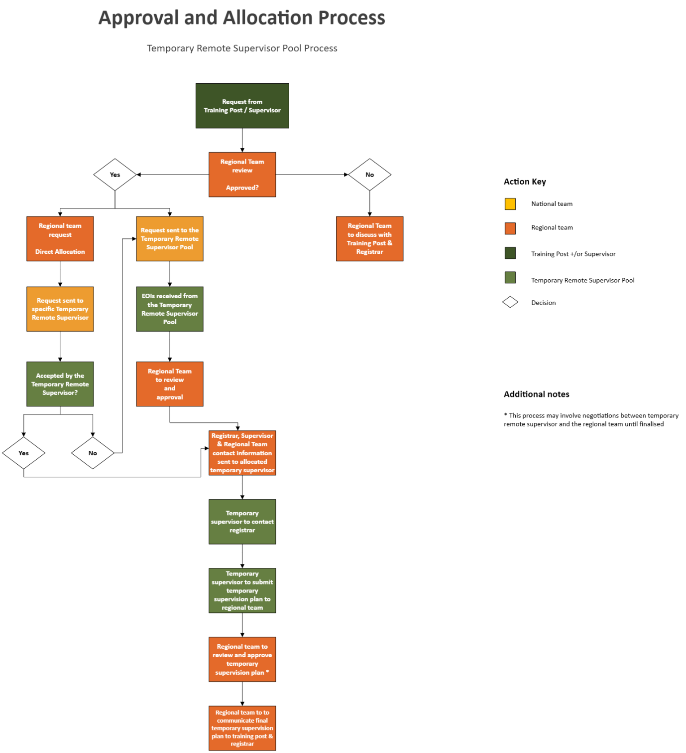
ACRRM acknowledges Aboriginal and Torres Strait Islander peoples as the custodians of the lands and waters where our members and staff work and live across Australia. We pay respect to their elders, lores, customs and Dreaming. We recognise these lands and waters have always been a place of teaching, learning, and healing.

